1st Cobham Scout Group
Welcome Pack



The Scout Hut
Hogshill Lane
Cobham
Surrey
KT11 2AH
www.cobhamscouts.org.uk

Welcome to 1st Cobham scout group this pack is designed to give you an introduction to our group and include all the information you need to know.

Please remember 1st Cobham scout group is entirely volunteer run and the leaders fit in activities around their jobs and family life. We always need your help whether as a leader, a committee member, or simply an extra pair of hands one night.

Times and Location

Scouts is held each week on a Wednesday 7:30pm – 9:00pm at the scout hut on Hogshill lane.

The Scout Hut
Hogshill Lane
Cobham
Surrey
KT11 2AH

Uniform

Scouts operates as a uniformed organization, and once your child has comfortably settled in, typically within a few weeks, we request that they wear their uniform. If they are moving up from cubs can they please continue to wear their cub uniform until they have a scout one.

There may be occasional activities where uniform is not mandatory, but our leaders will provide advance notice and guidance on such occasions.

Uniform consists of

- Green scout shirt
- 1st Cobham scarf and woggle (provided by the group)
- Blue scout activity trousers or school trousers
- Scout belt
- Suitable shoes for games and activities no sandals or slip on shoes

There are also blue scout shorts which can be worn on a Wednesday night however we don’t really recommend them and not many scouts choose to get them, as the cut in the children’s size looks a bit odd. Also the scouts will still need blue activity trousers or school trousers for parades and investitures etc.

Once a scout has their uniform they can be invested. At this time they will presented with their joining badges and 1st Cobham scarf and woggle.

We also have a blue 1st Cobham polo shirt, which is recommended for wear during camps and on occasions when the full uniform is not necessary. If you are interested in acquiring one, they are available for purchase through the group. Please speak to one of the leaders about them. Please remember the polo shirt is not a substitution for the green scout shirt but for times when uniform is not required.

Uniform can be purchased online from the scout store

https://shop.scouts.org.uk/scouts-sections/scouts

At the time of writing they do have a very good return policy if you want to try a few sizes but please do confirm this before buying.

There is also a scout shop in Guildford

Nightingale Road
Guildford
GU1 1ER

Opening times are limited so please check on their website

https://guildfordwestscouts.org.uk/scoutshop/

We understand that the expenses associated with a uniform can accumulate, and we want to ensure that no one misses out on this important aspect of scouting due to financial constraints. Our group has set aside funds specifically to assist individuals who may be facing difficulties covering the cost of a uniform. If you find yourself in need of financial assistance for a uniform, please don't hesitate to reach out to one of our leaders. We are here to support you and ensure that every scout can fully participate in the scouting experience. Your child's involvement is our priority, and we are here to help make it accessible to all.

Badges

Once a scout is invested they will be presented with their joining badges. Please see the diagram below for where these should be sewn onto the uniform and where the other badges they can earn during their time in scouts should go.
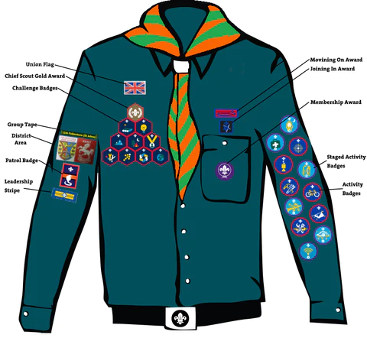
Initially when they join scouts they will be given

- the membership award badge
- group tape badge
- district area badge

Additionally if they have moved up from cubs they should have been given

- the moving on award
- they can take their joining in awards from their cub uniform (these denote the number of years they have been in scouts).
- If they have any staged activity badges like the nights away or hikes away (these count the number of nights/hikes they scout has done in their time with the movement) these can also be taken from their cub uniform.

More information on badges can be found or if anyone would like to work on their badges can be found https://www.scouts.org.uk/scouts/activity-badges/ and https://www.scouts.org.uk/scouts/awards/

Joining

For those not joining from cubs please complete the joining form and return it to a leader to then arrange a suitable night to start. If there are any details you wish to discus with the leaders then will be a good time to do so.

Email and WhatsApp

We send out message and reminders about what we are doing via email and our WhatsApp group. When you fill in the joining form you emails will automatically be added to the email list. Please let a leader know your phone number to be added to the WhatsApp group. We would like at least one parent/guardian on the WhatsApp group as we do sometimes send out last minute messages on there. Please note due to work commitments/getting themselves ready for scouts the leaders don’t check any messages sent on a Wednesday afternoon.

Program

Whilst we do often tell the scouts what we intend to do next week at the end of a Wednesday night. We do not publish our Wednesday program in advanced as we often have to rearrange our plans.

Online Scout Manager

We keep all our records in an online system called Online Scout Manager (OSM). Once you have completed the joining form a leader will add your details and you should be emailed with details to login. This will allow you to find out about and pay for camps, receive emails from the leaders, pay subs etc. You will also be asked at least once a year to confirm the details we hold about your child is still up to date. However if there are any changes in medical details, personal details etc please make sure they are updated as soon as possible and a leader informed of the change.

Costs

To help pay for our hut, insurance, utility and other running cost we charge a subscription fee per child. They are due at the start of each term in January, May and September. You will received an email from our online system when subs are due. This will include the current cost and how to pay. Please note the leaders do not have direct access to these payments so any queries will need to be taken up with the group treasurer.

Most smaller activity costs are covered in the subs but we may charge for some individual activities like camps, days out etc.

Like our uniform we also would not want anyone to miss out due to the cost and have funds to assist anyone who is having trouble paying. Please speak to a leader if this is the case.

